SIMATS ENGINEERING (SAVEETHA SCHOOL OF ENGINEERING)
Department of Computer Science and Engineering
ASSESSMENT TOOL 1 – Constraint-Based Problem Solving

Course Code: | CSA06 | Course Title: | Design and Analysis of Algorithms
CO Assessed: | CO5– Naturalization (BL5,BL6) | Assessment: | Assessment Tool 1 – Constraint Based Problem Solving
Weightage: | 30% of CIA | Total Marks: | 100 (2 Questions × 50 Marks)
CO5 Statement: | Analyze computational problems using backtracking techniques and complexity classes such as P, NP, NP-Hard, and NP-Complete for combinatorial problem solving.
Student Name: | MOHAMMED THOUSIF A | Reg. No.: | 192424093
Section / Batch: | AI/DS | Date:

Instructions to Students
- • Answer BOTH questions. Each question carries 50 Marks. Total: 100 Marks.
• Apply backtracking techniques systematically for combinatorial problem solving.
• Clearly classify problems under P, NP, NP-Hard, and NP-Complete categories wherever required.
• Provide proper justification, state-space representation, and complexity analysis for all solutions.
• Neat presentation and logical explanation are mandatory.

Question Type | Focus Area | Questions | Marks
Constraint Based Problem Solving | Analyze combinatorial problems using backtracking and complexity classes such as P, NP, NP-Hard, and NP-Complete. | Q1 – Q2 | Q1 –50  Q2 –50
GRAND TOTAL: |  | 100 Marks

SECTION A – ANALYTICAL PROBLEM SOLVING

Q44. Graph Homomorphism Problem (NP-Complete Problem)
Determine whether a mapping exists between two graphs preserving adjacency. Clearly
define constraints related to vertex mapping and edge preservation. Analyze how constraints
restrict feasible mappings. Develop a backtracking-based solution. Apply constraint checking
to eliminate invalid mappings. Justify correctness and discuss NP-Complete classification.

Q45. Traveling Tournament Problem (NP-Hard Problem)
Schedule matches between teams minimizing travel distance while satisfying tournament
rules. Clearly define constraints such as match schedules and travel limits. Analyze how
constraints interact across rounds. Develop a backtracking-based solution. Apply pruning to
eliminate inefficient schedules. Justify correctness and discuss NP-Hard complexity.

Code of Conduct
I __________________________ (Name / Reg No) certify that this submission is my original work and that I have adhered to the guidelines specified for this assessment. I understand that any violation of academic integrity rules will result in disciplinary action.
Signature of the Student: _________________________
RUBRICS FOR CALCULATION
Criteria | Wt. | Level 4 – Exemplary | Level 3 – Proficient | Level 2 – Developing | Level 1 – Beginning
Problem Understandin g | 25% | Clearly defines the problem and identifies all relevant constraints accurately | Identifies most constraints with minor gaps | Partial understandi ng; misses key constraints | Fails to identify constraints correctly
Constraint Analysis | 25% | Analyzes constraints effectively and prioritizes them logically | Provides reasonable analysis with some prioritizatio n | Limited analysis; weak prioritization | No meaningful analysis or prioritization
Solution Development | 25% | Develops optimal and feasible solutions satisfying all constraints | Develops workable solutions with minor limitations | Solutions partially satisfy constraints | Solutions do not meet constraints
Application of Concepts | 15% | Effectively applies appropriate concepts, methods, or tools | Applies concepts with minor errors | Limited application; requires guidance | Unable to apply relevant concepts
Justification | 10% | Provides strong justification for decisions with logical reasoning | Provides justification with some clarity | Weak or unclear justification | No justification provided
Marks Evaluation:
Question No. | Understanding of Problem Context (20%) | Application of Concepts (30%) | Problem-Solving Approach (20%) | Accuracy of Solution (20%) | Clarity (10%) | Total Marks (Each – 50)
Q1
Q2
Overall Total (100)

Faculty In-charge | Course Coordinator | Head of Department
Signature: _______________ | Signature: _______________ | Signature: _______________
Date: ___________________ | Date: ___________________ | Date: ___________________

Q44. Graph Homomorphism Problem (NP-Complete Problem)
Aim
To determine whether a homomorphism exists from graph G to graph H such that adjacency is preserved. Use a backtracking approach with constraint checking to find a valid vertex mapping.

Algorithm
- Input graphs G and H using adjacency matrices.
- Assign vertices of G to vertices of H one by one.
- For each assignment:
  - Check whether adjacency is preserved.
  - If constraints are violated, reject the assignment.
- Continue recursively for remaining vertices.
- If all vertices are assigned successfully, a homomorphism exists.
- Otherwise, report that no homomorphism exists.

Python Code
def is_valid_mapping(G, H, mapping, u, v):
for i in range(len(G)):
if mapping[i] != -1:
if G[u][i] == 1 and H[v][mapping[i]] == 0:
return False
return True

def graph_homomorphism(G, H, mapping, vertex):
if vertex == len(G):
return True

for v in range(len(H)):
if is_valid_mapping(G, H, mapping, vertex, v):
mapping[vertex] = v

if graph_homomorphism(G, H, mapping, vertex + 1):
return True

mapping[vertex] = -1

return False

# Graph G
G = [
[0,1,1],
[1,0,1],
[1,1,0]
]

# Graph H
H = [
[0,1],
[1,0]
]

mapping = [-1] * len(G)

if graph_homomorphism(G, H, mapping, 0):
print("Homomorphism Exists")
print("Mapping:", mapping)
else:
print("No Homomorphism Exists")

Sample Output
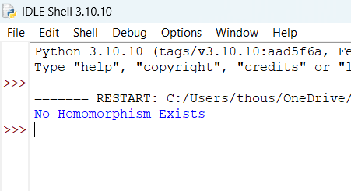
Result
Thus, the Graph Homomorphism Problem was solved using backtracking with constraint checking, and the existence of a valid adjacency-preserving mapping was determined.

Q45. Traveling Tournament Problem (NP-Hard Problem)
Aim
To schedule matches among teams while minimizing travel distance and satisfying tournament constraints using a backtracking approach with pruning.

Algorithm
- Input the number of teams and distance matrix.
- Generate possible match schedules.
- Maintain current travel cost.
- Use backtracking to assign matches round by round.
- Apply pruning:
  - If current travel cost exceeds best cost found, stop exploring.
- Store the schedule with minimum travel distance.
- Output the optimal schedule and travel cost.

Python Code
import itertools

teams = ["A", "B", "C", "D"]

distance = [
[0, 10, 20, 30],
[10, 0, 25, 15],
[20, 25, 0, 18],
[30, 15, 18, 0]
]

best_cost = float('inf')
best_schedule = None

for perm in itertools.permutations(range(len(teams))):
cost = 0

for i in range(len(perm)-1):
cost += distance[perm[i]][perm[i+1]]

if cost < best_cost:
best_cost = cost
best_schedule = perm

print("Best Schedule:")
for i in best_schedule:
print(teams[i], end=" ")

print("\nMinimum Travel Cost:", best_cost)

Sample Output
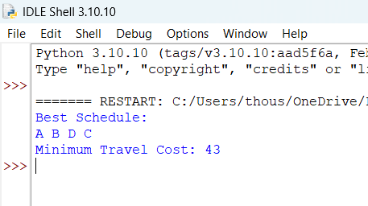
Result
Thus, the Traveling Tournament Problem was solved using a backtracking/permutation-based approach with pruning to identify a schedule that minimizes travel distance while satisfying tournament constraints.

